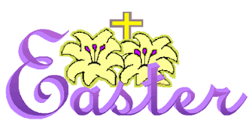
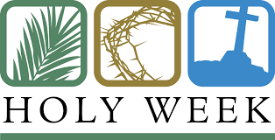

to

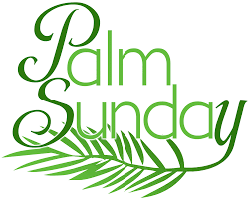
April 12 – 19, 2017
9:00 a.m.
St. Paul’s Church, Angelica
11:00 a.m.
Christ Church, Cuba
April 12, 2017
The Palm Sunday Liturgy
with the distribution of palms
and
The Holy Eucharist, Rite II

5:00 p.m.
St. Paul’s Church, Angelica
7:00 p.m.
Christ Church, Cuba
April 17, 2017
The Good Friday Liturgy
5:00 p.m. Christ Church, Cuba
7:00 p.m. St. Paul’s Church, Angelica
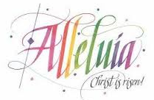
9:00 a.m.
St. Paul’s Church, Angelica
11:00 a.m.
Christ Church, Cuba
April 19, 2017
Easter Day
Festival Holy Eucharist, Rite II
in the Church

Easter Flower Prayer Requests
Please remember the following persons in the prayers on Easter Day:

PLEASE RETURN THE EASTER FLOWER PRAYER REQUESTS TO CHURCH ON PALM SUNDAY or

Email names to Fr. Hamlin by Wednesday, April 12 at Hamlinhill@verizon.net or

Mail to The Rev. Richard Hamlin, 6258 County Road 31A, Friendship, N.Y. 14739

